
COMSATS University Islamabad,
Sahiwal Campus.

Rento Car

A Project Presented To

COMSATS University Islamabad,
Sahiwal Campus

In partial fulfillment

of the requirement for the degree of

Bachelor of Science in Software Engineering (2021-2025)

By

Adeel Parvez | CIIT/FA21-BCS-202/SWL
Sawera Nayyab | CIIT/FA21-BCS-230/SWL

COMSATS University Islamabad,
Sahiwal Campus.

Rento Car
By

Adeel Parvez | CIIT/FA21-BCS-202/SWL
Sawera Nayyab | CIIT/FA21-BCS-230/SWL

Supervisor
Mr. Tahir Khalil

Bachelor of Science in Software Engineering (2021-2025)

The candidate confirms that the work submitted is their own and appropriate credit has been given where reference has been made to the work of other

DECLARATION
We hereby declare that this software, neither whole nor as a part has been copied out from any source. It is further declared that we have developed this software and accompanied report entirely based on our personal efforts. If any part of this project is proved to be copied out from any source or found to be reproduction of some other. We will stand by the consequences. No Portion of the work presented has been submitted of any application for any other degree or qualification of this or any other university or institute of learning.

Sawera Nayyab
Adeel Parvez

CERTIFICATE OF APPROVAL
It is to certify that the final year project of BS(CS) “Rento Car” was developed by Adeel Parvez(CIIT/FA21-BCS-202/SWL) and Sawera Nayyab (CIIT/FA21-BCS-230/SWL) under the supervision of “Mr. Tahir Khalil” and co-supervisor “Miss Mubeen” and that in their opinion; it is fully adequate, in scope and quality for the degree of Bachelors of Science in Software Engineering.

---------------------------------------

Supervisor
Mr. Tahir Khalil
Lecturer
Department of Computer Science
COMSATS University Islamabad, Sahiwal Campus

---------------------------------------

Head of Department
Dr. Zafar Iqbal Roy
Assistant Professor
Department of Computer Science
COMSATS University Islamabad, Sahiwal Campus

Executive Summary
"Rento Car" is a comprehensive mobile-based car rental and transportation management application designed to revolutionize the way individuals and agencies rent or deliver vehicles in Pakistan. The core objective of this application is to provide users with an easy-to-use, efficient, and secure platform where they can rent cars with or without drivers, and also arrange intercity vehicle deliveries — all from the comfort of their mobile phones.
This application offers dual modules: one for users (customers) and one for administrators. Users can easily browse available vehicles, make bookings, select payment options, and track their rented or shipped vehicles in real time using GPS. Admins, on the other hand, can manage bookings, upload or remove vehicles, update details, track delivery status, and respond to customer issues. The app supports vehicle owners and car rental businesses by providing a digital presence and direct access to potential customers.
Developed using Flutter for frontend and Firebase for backend services, the app offers cross-platform compatibility, fast performance, and secure data management. Features such as authentication, secure payments, order tracking, and notification systems are integrated to enhance user trust and system functionality.
To ensure a reliable and scalable product, the development process followed Agile methodology with proper sprint planning, documentation, testing (unit, functional, and integration), and user feedback loops. Furthermore, the app's user interface (UI) is designed to be clean and user-friendly, accommodating users of varying technical skill levels.
In conclusion, "Rento Car" is not just an app but a complete digital solution for car rental and delivery operations. It empowers both users and businesses by simplifying the traditional rental model, ensuring transparency, safety, and convenience. Through this innovative solution, we aim to modernize Pakistan's vehicle rental landscape and open new avenues for mobility and logistics services.

Acknowledgment
All praise is to almighty Allah who bestowed upon us a minute portion of his boundless knowledge by which we were able to accomplish this challenging task.
We are greatly indebted to our project supervisor “Mr. Tahir Khalil” and our Co-Supervisor “Miss Mubeen”. Without their supervision, advice, and valuable guidance, the completion of this project would have been doubtful. We are deeply indebted to them for their encouragement and continual help during this work.
And we are also thankful to our parents and family who have been a constant source of encouragement for us and brought us the values of honesty & hard work.

Sawera Nayyab
Adeel Parvez

Abbreviations
API | Application Programming Interface
JS | JavaScript
SRS | Software Requirements Specification
SDD | Software Design Description
GUI | Graphical User Interface
IDE | Integrated Development Environment
GPS | Global Positioning System
UI/UX | User Interface / User Experience
MVC | Model-View-Controller
DB | Database
FCM | Firebase Cloud Messaging
CRUD | Create, Read, Update, Delete

Table of Contents
Chapter 1 Introduction
1 Introduction 1
1.1 Brief Overview 1
1.2 Relevance to Course Modules 2
1.2.1 Technical Skills: 2
1.2.2 Software Engineering Principles: 2
1.2.3 Database Design: 2
1.2.4 System Architecture: 3
1.2.5 UI/UX Design: 3
1.2.6 Project Management: 3
1.2.7 Networking: 3
1.3 Project Background 4
1.4 Literature Review 5
1.5 Methodology and Software Lifecycle 5
1.5.1 Rationale Behind Selected Agile Model (Extended) 6
Chapter 2 Problem Definiton
2 Problem Definition 10
2.1 Problem Statement 10
2.2 Deliverables and Development Requirements 11
2.2.1 Core Features and Functionalities 11
2.2.2 Technical and Development Requirements 12
2.2.3 Maintenance and Future Enhancements 12
2.3 Expected Outcome 13
Chapter 3 Requirement Analysis
3 Requirement Analysis 15
3.1 Use Case Diagrams 15
3.2 Use Case Descriptions 16
3.3 Functional Requirements 22
3.3.1 User Registration and Authentication 22
3.3.2 Car Booking and Management 23
3.3.3 Secure Payments 23
3.3.4 Real-Time Tracking 23
3.3.5 Admin Dashboard 23
3.3.6 Booking Confirmation and Receipt Generation 23
3.3.7 Personalized Recommendations 24
3.4 Nonfunctional Requirements 24
3.4.1 Performance 24
3.4.2 Security 24
3.4.3 Scalability 25
3.4.4 Accessibility 25
3.4.5 Usability 25
Chapter 4 Design and Architecture
4 Design and Architecture 27
4.1 System Architecture 27
4.2 Architecture Design 27
4.3 Process Flow/Representation 27
4.3.1 User Registration & Login (Mobile App) 28
4.3.2 User Dashboard (Mobile App) 28
4.3.3 Car Booking Flow (Mobile App) 28
4.3.4 Car & Trip Tracking (Admin Web Panel) 28
4.3.5 Car Return Process (Mobile App) 28
4.3.6 Logout & Session Termination 28
4.4 Sequence Diagram 30
4.4.1 Registration and Login Process: 30
4.4.2 2. Booking Process: 30
4.4.3 Car Return Process: 30
4.4.4 Payment Management: 30
4.4.5 Customer Management: 30
4.4.6 Car Fleet Management: 31
4.47 Report Generation: 31
4.4.7 Conclusion: 31
4.5 Class Diagram 32
4.5.1 Login & Signup Modules: 32
4.5.2 Customer Entity: 33
4.5.3 Admin Entity: 33
4.5.4 Booking Entity: 33
4.5.5 Car Entity: 33
4.5.6 Payment Entity: 33
4.5.7 Rental Agreements Entity: 34
4.5.8 Car Return Entity: 34
4.5.9 Invoice Entity: 34
4.5.10 Tracking Entity: 34
4.6 Data Flow Diagrams 36
4.6.1 Level 0 DFD 36
4.6.2 Level 1 DFD 37
4.6.3 Level 2 DFD Explanation 39
Chapter 5 Implementation
5 Implementation 42
5.1 User Registration Algorithm 46
5.2 Real-Time Booking Data Management 47
5.3 Security and Data Protection 47
5.4 User Interface 48
5.4.1 Welcome Screen 48
5.4.2 Car Booking & Shipping Interface: 49
5.4.3 Sign Up 51
5.4.4 Login 52
5.4.5 Location Access & Search 54
5.4.6 Home Screen 55
Chapter 6 Testing and Evaluation
6 Testing 58
6.1 Unit Testing 58
6.2 Manual Testing 59
6.3 Functional Testing 60
6.4 Integration Testing 61
6.5 System Testing 62
Chapter 7 Conclusion and Future Work
7 Conclusion and Future Work 66
7.1 Conclusion 66
7.2 Future Work 66
7.2.1 In-App Chat Support 67
7.2.2 AI-Powered Car Suggestions 67
7.2.3 Vehicle Condition Reporting with Image Upload 67
7.2.4 Enhanced Admin Dashboard (Web-Based) 67
7.2.5 Expansion of Payment Methods 68
7.2.6 Multilingual Support 68
7.2.7 Integration with Advanced Map APIs 68
7.2.8 Expanding Language Support 68
7.2.9 Deeper Data Analyzer 69
References 70

List of Figures
Figure 1.1 Agile Methodology 8
Figure 3.1 Use Case Diagram 15
Figure 4.1 Agile Methodology 27
Figure 4.2 Flow-chart 29
Figure 4.3 Sequence Diagra 32
Figure 4.4 Class Diagram 35
Figure 4.5 Data Flow diagram Level0 37
Figure 4.6 Data Flow Diagram Level1 38
Figure 4.7 Data Flow Diagram Level2 40
Figure 5.1 Welcome Screen 49
Figure 5.2 Booking Screen 50
Figure 5.3 Sign Up Screen 52
Figure 5.4 Login Screen 53
Figure 5.5 Locations Screen1 54
Figure 5.6 Location Screen2 55
Figure 5.7 Home Page 56
List of Tables
Table 1.1 Comparison with other similar Apps 5
Table 3.1 Use Case Authentication 16
Table 3.2 Use case Get Registration 16
Table 3.3 Use Case View Car 17
Table 3.4 Use case Car Details and Price 17
Table 3.5 Use Case Request Booking 18
Table 3.6 Use case Sign Agreement 19
Table 3.7 Use Case Make Payment 19
Table 3.8 Use case Manage Car Fleet 20
Table 3.9 Use case Sign Agreement 20
Table 3.10 Use Case Manage Bookings 21
Table 3.11 Use case Manage Payments 22
Table 6.1 Unit Testing 58
Table 6.2 Manual Testing 59
Table 6.3 Functional Testing 61
Table 6.4 Integration testing 62
Table 6.5 System Testing 63

Chapter 1

Introduction

Introduction
In today’s fast-paced digital era, the transportation industry is undergoing a technological revolution, especially in vehicle rentals and shipping services. Recognizing the increasing demand for convenience, security, and automation, we propose the development of Rento Car, a powerful mobile application designed to simplify the process of renting vehicles and shipping them to desired locations without the need for direct dealer interaction.
Rento Car is envisioned as a premium platform offering customers a seamless experience to rent cars with or without drivers and also ship vehicles locally or intercity through a transparent and trackable process. This app ensures customers can complete bookings in just a few clicks while enjoying real-time tracking, secure payments, and timely support.
One of the standout features of Rento Car is its dual module system supporting both customers and administrators. Users can select, book, and track cars for rent or shipping, while admins can manage listings, bookings, payments, and overall system health.
Additionally, Rento Car supports vehicle owners or rental agencies by providing them with an efficient way to connect with potential clients and grow their business reach, thereby fostering a tech-savvy transportation community.
The development of Rento Car leverages cutting-edge technologies, including a frontend built using Flutter (for cross-platform support) and a robust backend supported by Firebase. This technology stack guarantees a responsive, secure, and scalable system for all users.

Brief Overview
Rento Car is an innovative mobile-based vehicle rental and shipping platform aimed at revolutionizing how people rent cars and ship them across cities. With rising expectations around real-time tracking, flexibility, and digital convenience, Rento Car acts as a one-stop solution for users seeking to rent vehicles or transport them without the involvement of intermediaries.
The app enables users to rent cars with or without drivers, schedule intercity vehicle shipments, and track their entire journey through GPS. Bookings are quick and payments are securely managed through integrated online gateways.
In addition to customer features, Rento Car offers a dedicated admin panel where service providers or vehicle owners can manage their inventory, booking status, customer interactions, and track deliveries.
By supporting both end users and business owners, the platform creates a mutually beneficial environment that boosts transparency, convenience, and business expansion opportunities.
Built using Flutter and Firebase, Rento Car delivers a fast, smooth, and secure mobile experience, positioning it as a forward-thinking transportation solution.

Relevance to Course Modules
This project is deeply rooted in core modules of the Computer Science curriculum, effectively translating classroom theories into a practical, real-world solution. By combining various subjects such as mobile app development, database systems, software engineering, human-computer interaction, and networking, this project serves as a capstone that demonstrates the integration of multidisciplinary knowledge.

Technical Skills:
Throughout the development of the Rento Car application, students applied multiple programming tools and frameworks learned in coursework. Flutter and Dart were used for cross-platform mobile app development, demonstrating their understanding of UI components, state management, and widget trees. Firebase Authentication was used to securely manage user login/signup processes, while Firestore provided a real-time cloud-based database system. The payment gateway integration further showcased the application of third-party API handling, asynchronous operations, and secure financial transaction practices — all essential technical skills taught in advanced development modules.

Software Engineering Principles:
The project strictly adheres to modern software engineering principles. It uses a modular and layered architecture that separates UI, business logic, and data handling components. This ensures the maintainability and scalability of the app. Concepts such as requirement gathering, use case development, UML diagrams, proper code documentation, unit testing, and version control were incorporated, aligning closely with what is taught in the Software Engineering course. The development lifecycle followed an Agile methodology with iterative releases and sprint planning, ensuring continuous improvement.

Database Design:
The backend structure of the application is based on Firebase Firestore, a NoSQL database. Students applied theoretical knowledge of database concepts such as data modeling, normalization, and secure access control. Firestore collections and documents were carefully designed to optimize data retrieval and storage. The design included users, bookings, vehicle listings, and shipping records, ensuring efficient indexing and minimizing read/write costs reflecting strong database design skills.

System Architecture:
The system’s design reflects the MVC (Model-View-Controller) architecture principles. This architectural pattern enhances the separation of concerns, helping in isolating the business logic from the user interface and database operations. The modular structure makes the application scalable, allowing additional features such as car maintenance records or customer reviews to be added with minimal code changes. These principles were learned in system design and software architecture courses and were effectively applied in the implementation.

UI/UX Design:
Drawing upon concepts from Human-Computer Interaction (HCI) and UI/UX design courses, the Rento Car app was crafted with a user-centric approach. The interface is designed to be clean, intuitive, and responsive. Elements such as interactive forms, clearly labeled buttons, dark mode compatibility, and real-time validation contribute to a seamless user experience. Admin panels are structured with accessible menus and dashboards, making them easy to navigate and manage bookings or car listings.

Project Management:
Agile project management principles were employed throughout the project’s development cycle. Weekly sprints, task breakdowns, and milestone tracking were performed using Trello. GitHub was used for source code management, issue tracking, and team collaboration. These tools and methodologies reflect concepts taught in project management and software engineering process modules, including risk assessment, timeline estimation, and iterative feedback loops.

Networking:
The app integrates real-time features such as live GPS vehicle tracking and instant updates on booking status. These require strong networking fundamentals, particularly the use of RESTful APIs and WebSocket-like behavior supported by Firebase. Concepts such as HTTP requests, JSON parsing, asynchronous programming, and internet connectivity checks were implemented, showcasing a solid understanding of networking protocols and mobile app integration techniques learned in networking modules.

Project Background
The traditional car rental and shipping industry in Pakistan still heavily relies on manual bookings, phone calls, and physical verification — a process that is often time-consuming, inefficient, and prone to human error. There is a noticeable absence of digital platforms that can automate and simplify these services, particularly for users who demand transparency, convenience, and real-time updates.
Rento Car was conceived to fill this digital void in the local market. It aims to modernize the vehicle rental and shipping process by providing an app-based solution that is accessible, efficient, and secure. The idea stems from common user pain points: not being able to compare rental prices easily, lack of availability during peak seasons, delays in communication, and the inability to track car shipments in real-time.
With Rento Car, users can create an account, browse available vehicles, book rentals with or without a driver, and track the car using GPS-based updates — all from within the app. The shipping feature allows customers to transport their personal vehicles between cities with the help of trusted logistics providers, minimizing the need for physical coordination.
On the backend, admins can upload new vehicles, manage user bookings, process payments, and approve or cancel shipping requests, all through a dedicated web dashboard. This level of automation ensures higher efficiency and less manual overhead, while also making the entire system more transparent for end users.
The use of Flutter ensures cross-platform compatibility, providing a native-like experience on both Android and iOS devices. Firebase was chosen for its powerful real-time capabilities, secure authentication, and scalable cloud database. The use of modern development tools and agile practices ensures that the app can be maintained and improved continuously based on user feedback and evolving market trends.
Ultimately, this project not only solves a real-world problem but also provides students with valuable experience in full-stack mobile development, making it an ideal integration of theory and practical application.

Literature Review
A comprehensive review of existing vehicle rental and shipping platforms revealed that while many apps offer vehicle rentals or delivery individually, very few combine both services in a streamlined mobile experience with real-time tracking and smart admin controls.
Comparisons with other related apps are as follows:
Table 1.1 Comparison with other similar Apps
Existing System | Drawbacks | Proposed System Solutions
Careem / Uber Rentals | Offers cars with drivers only — no self-drive or car shipping option | Rento Car allows with/without driver booking + vehicle shipping
PakWheels Shipping | Provides only shipping without real-time updates or booking flexibility | Rento Car offers full booking control, GPS tracking, and payments.
Traditional Agencies | Mostly offline,no real-time tracking,manual paperwork | Rento Car is fully digital and automated

Methodology and Software Lifecycle
The development of the Rento Car application follows the Agile Software Development Lifecycle (SDLC). This methodology emphasizes flexibility, customer collaboration, and the delivery of working software in iterative cycles. Due to the dynamic nature of mobile app development and the ever-evolving expectations of users, Agile was chosen over traditional models like Waterfall, which lack flexibility for changes after initial planning.
Agile methodology allowed the development team to break down the entire project into manageable units called sprints, each lasting one to two weeks. At the beginning of each sprint, tasks were planned collaboratively, and at the end, a review or retrospective helped identify areas for improvement. This approach led to continuous progress, faster bug fixing, early user testing, and quick adaptation to stakeholder feedback.
By applying Agile, the team ensured that core features like user authentication, car rental booking, shipping requests, and admin panel functionalities were developed, tested, and refined in multiple cycles — improving the overall quality and user experience.
Development was further supported by tools such as:
- Trello for sprint planning and task tracking.
- GitHub for source code management and version control.
- Firebase App Distribution for early releases and testing.
- User feedback forms to gather opinions from real users during test phases.
The combination of Agile principles and collaborative tools created a transparent and productive development environment that supported rapid iteration, bug resolution, and enhancement of features based on real-time insights.

Rationale Behind Selected Agile Model (Extended)
The choice of Agile methodology was guided by the specific needs of the Rento Car project — a mobile app that needed to evolve with user expectations, emerging technologies, and business requirements. Traditional models, such as the Waterfall model, would not have allowed mid-project changes without major disruptions. On the other hand, Agile provided the flexibility to incorporate frequent changes, manage complexity, and deliver value continuously.
Rento Car is not just a static product but a service-oriented platform. Features such as live GPS tracking, push notifications, payment gateway integration, and chat support required real-time feedback from test users for refinement. Agile made it possible to experiment, evaluate, and improve these features over time without restarting the entire development process.
Key reasons for choosing the Agile model include:
- User-Centered Design: Agile encourages constant user involvement through demos, reviews, and feedback cycles. This helped shape features based on actual user needs rather than assumptions.
- Faster Time-to-Market: Agile enabled early delivery of a minimum viable product (MVP), which users could interact with even before the full version was complete. This accelerated learning and helped identify critical improvements early on.
- Improved Collaboration: With daily standups and sprint reviews, the team maintained clear communication, reducing misunderstandings and improving overall productivity.
- Risk Management: Frequent testing and integration reduced the chances of last-minute failures or technical debt, ensuring smoother progress.
- Scalability: Agile allowed for future-ready planning, enabling the easy addition of modules like driver verification, ride history, or multilingual support in future sprints.

Core Principles of Agile as Applied in This Project:
- Iterative Development: Every feature was developed in small chunks, refined through multiple iterations, and improved with each version. For example, the booking process started as a basic form and was later enhanced with date/time pickers, dropdowns, and validations.
- Incremental Delivery: After every sprint, a functional update was shared with testers or mentors, allowing them to experience new functionalities and provide instant feedback.
- Continuous Feedback: The team actively collected feedback from both end-users and supervisors. This helped in refining user flows, removing redundant features, and enhancing usability.
- Adaptive Planning: Instead of rigid plans, the team updated the roadmap after every sprint based on test results and new ideas. This helped in reprioritizing features such as in-app messaging and vehicle status alerts.
In conclusion, the Agile approach was not just a project management decision — it was a strategic framework that matched the project’s requirements for flexibility, speed, and user involvement. It ensured that the development team could stay focused on quality while adapting to feedback, market trends, and technological advancements.
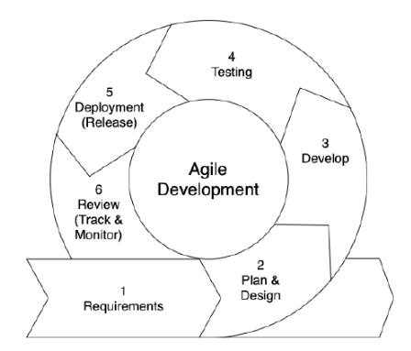
Figure 1.1 Agile Methodology

Chapter 2

Problem Definition

Problem Definition
This chapter discusses the precise problem to be solved by the Rento Car application and outlines the desired outcomes. It provides a detailed description of the current limitations in the vehicle rental and shipping industry and presents the technical and functional requirements needed to overcome those limitations.

Problem Statement
Despite the increasing demand for convenient and digital transportation solutions, users still face considerable challenges when renting vehicles or arranging for car shipping. Many existing platforms either lack delivery options or do not provide flexibility in choosing whether to book with or without a driver. Additionally, customers often struggle with locating reliable, nearby car rental options that suit their specific needs. The lack of real-time tracking and communication also leads to uncertainty and poor customer satisfaction.
On the other hand, car rental businesses, especially small vendors, face difficulties in reaching a larger customer base due to limited digital presence and inefficient management tools. Without robust platforms, many businesses struggle to organize their inventory, manage bookings, or ensure customer satisfaction. As competition grows, businesses that lack digital efficiency are left behind, resulting in lower profitability and reduced market reach.
Vehicle shipping also remains a fragmented experience, with few platforms offering an integrated solution for both customers and administrators. Customers often rely on multiple service providers for transportation, scheduling, and payments. This causes confusion, unclear pricing, communication gaps, and inefficient service delivery. Furthermore, there are very few systems that allow users to track the delivery of their vehicles in real time or to contact the service providers directly when problems arise.
These inefficiencies result in delays, mismanagement, and poor user experiences. Consequently, there is a clear and urgent need for a centralized, user-friendly, and integrated system that streamlines the process of both car rental and vehicle shipping. This system must be accessible to users of all technical skill levels and scalable to serve both small vendors and larger rental businesses. The ideal solution should bridge the gap between customers and service providers, providing a trustworthy and seamless experience on both ends.

Deliverables and Development Requirements
The Rento Car project aims to provide a comprehensive digital platform that offers both car rental and vehicle shipping services. The system will support bookings with or without a driver, integrate real-time car delivery tracking, ensure secure payments, and provide administrative features for business owners to manage their vehicles and track customer orders.
To meet these goals, the system will be built on a strong foundation of technical and functional requirements that ensure usability, reliability, and performance. These requirements are categorized and outlined as follows:

Core Features and Functionalities
The following features will be implemented in the mobile app to ensure that users and administrators enjoy a seamless and feature-rich experience:
- User Authentication & Security:
A secure login and registration system to protect user data. Passwords and sensitive information will be stored using encryption techniques. Users will have access to account recovery options, profile management, and secure transaction history.
- Booking & Rental Options:
Users will be able to view available cars, filter by brand, model, price, and features, and select whether they want the car delivered with or without a driver. They can also schedule bookings based on their preferences.
- Vehicle Shipping Integration:
Users will be able to request vehicle shipping services, enter pickup and drop-off locations, and receive accurate pricing estimates. Shipping requests will be processed using automated scheduling tools.
- Real-Time Tracking:
A GPS-based tracking feature will allow users to monitor the status of their rental vehicle or shipped car in real time. Notifications will keep users updated about delivery times, route changes, or delays.
- Payment Gateway:
The app will support multiple payment methods including credit/debit cards, mobile wallets, and bank transfers. All payments will be processed securely and receipts will be generated.

Technical and Development Requirements
- User Interface (UI) Design:
A modern, intuitive, and mobile-responsive interface built using Flutter to ensure consistency across Android and iOS. The UI will emphasize ease of use, with clear navigation and visually appealing layouts.
- Scalability and Performance:
The platform will be designed with scalability in mind, utilizing cloud services to support thousands of users and transactions without performance degradation.
- Cross-Platform Compatibility:
Development will be focused on Flutter to ensure seamless functionality across various device types and screen sizes, maintaining a uniform experience for all users.
- Admin Dashboard:
An admin panel will allow rental service providers to manage car listings, view orders, approve or reject bookings, and monitor delivery statuses. They will also have access to analytics and reports.

Maintenance and Future Enhancements
To ensure long-term success and relevance of the platform, the following steps will be taken:
- Regular Updates:
The application will be updated periodically to fix bugs, enhance features, and integrate new technologies based on user feedback.
- Customer Support Integration:
A dedicated support section with chatbot assistance and human support channels to help users resolve issues quickly.
- Feedback System:
Users will be encouraged to rate their rental or shipping experience. These reviews will be visible on the app to build trust and improve service quality.
- Analytics and Reporting:
The system will include tools for analyzing user behavior, sales trends, and vehicle utilization, helping administrators make informed decisions.

Expected Outcome
The implementation of the Rento Car platform is expected to result in:
- Increased accessibility and convenience for users seeking car rentals or shipping services.
- Improved efficiency, order tracking, and customer satisfaction due to real-time features.
- Greater visibility and operational control for service providers.
- A more integrated and digitized vehicle rental ecosystem in Pakistan and beyond.
Ultimately, the goal is to develop a robust, scalable, and user-centric platform that transforms the current vehicle rental and shipping experience making it modern, reliable, and efficient for all stakeholders.

Chapter 3

Requirement Analysis

Requirement Analysis
Requirement analysis for Rento Car involves a thorough investigation into the essential functionalities required for the successful development of the car rental and vehicle shipping platform. This process includes gathering and analyzing user needs, technical feasibility, and market trends in the car rental and logistics industry. The outcome is a clear and detailed specification that guides the entire development lifecycle, ensuring the platform delivers an intuitive and reliable service for users and clients.

Use Case Diagrams
-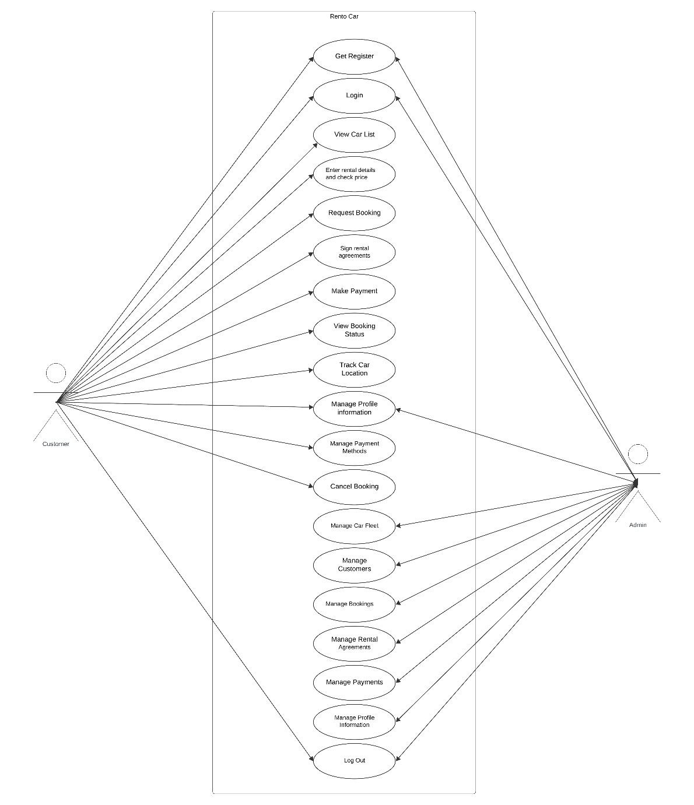
Figure 3.1 Use Case Diagram

Use Case Descriptions
The table below indicates comprehensive use case descriptions

Table 3.1 Use Case Authentication
Use case id | 01
Use case name | Authentication
Actors | Admin User
Description | A user of the System logs into the System.
Trigger | User requests to log in.
Pre-condition | The user has an account.
Post-condition | The actor is now logged into the system.
Normal flow | This use case starts when an actor wants to log into the system.
Alternative flow | If credentials are incorrect, an error message is shown.
Exceptions | Incorrect login credentials.
Business rules | The system must be connected to the network.

Table 3.2 Use case Get Registration
Use case id | 02
Use case name | Get Registration
Actors | User Admin
Description | A user of the System creates an account.
Trigger | Select the register link
Pre-condition | The user doesn't have an account yet.
Post-condition | The user’s details are stored in the database.
Normal flow | The user selects the registration option, fills in their details, and the system creates their account.
Alternative flow | If the user cancels, the system discards the information and returns to the home page.
Exceptions | If the user already exists, an error message is shown.
Business rules | The system must be online for registration

Table 3.3 Use Case View Car
Use Case ID | 03
Use Case Name | View Car List
Actors | Customer
Description | Customers can view a list of available cars, including filtering by car features and price range.
Trigger | User wants to view the car list.
Pre-condition | The user is logged in to the system.
Postcondition | The customer views the list of available cars.
Normal Flow | The user logs in to the system and views the car list.
Alternative Flow | If the user is not registered, they cannot view the available cars.
Exceptions | Error occurs in the application. Server is down.
Business Rules | User registration is required.

Table 3.4 Use case Car Details and Price
Use Case ID | 04
Use Case Name | Enter Rental Details and Check Price
Actors | Customer
Description | The customer enters rental details and checks the price.
Trigger | Customers want to book a car for rental.
Pre-condition | The customer must be registered on the app.
Postcondition | The customer receives a price estimate based on rental details.
Normal Flow | The customer logs in to the system and successfully enters rental details. The system provides a price estimate.
Alternative Flow | Admin does not accept the request. No car is available for the requested rental details.
Exceptions | There is no internet. Server is down.
Business Rules | The request is rejected if the customer does not provide sufficient rental details.

Table 3.5 Use Case Request Booking
Use Case ID | 05
Use Case Name | Request Booking
Actors | Customer
Description | After entering rental details, the customer confirms the booking request.
Trigger | Customers want to book a car.
Pre-condition | The customer must be registered and have entered rental details.
Postcondition | A confirmation message is received by the customer.
Normal Flow | The customer logs in to the system, enters rental details, and requests a booking.
Alternative Flow | Admin does not accept the request. No car is available for the requested rental details.
Exceptions | There is no internet. Server is down.
Business Rules | The request is rejected if the customer does not provide sufficient rental details.
Table 3.6 Use case Sign Agreement
Use Case ID | 06
Use Case Name | Sign Rental Agreement
Actors | Customer
Description | The customer signs the rental agreement electronically.
Trigger | Confirm all checks and sign the agreement.
Pre-condition | The customer has pressed the “sign the agreement” button.
Postcondition | The agreement has been signed electronically.
Normal Flow | The customer logs in to the system, checks rental details and price, and signs the agreement.
Alternative Flow | The customer cancels the agreement. There are conflicts regarding rental terms.
Exceptions | Issues with electronic signature process.

Table 3.7 Use Case Make Payment
Use Case ID | 07
Use Case Name | Make Payment
Actors | Customer, Admin
Description | After signing the agreement, the customer selects a payment method and confirms payment. The admin manages payments and processes refunds if necessary.
Trigger | Customers want to confirm payment. Admin manages payments.
Pre-condition | The customer must be registered and have an active booking.
Postcondition | The customer receives a payment confirmation.
Normal Flow | The customer logs in to the system, selects a payment method, and confirms payment. The admin processes the payment.
Alternative Flow | The customer does not log in. The customer cannot access the user account.
Exceptions | There is no internet. The application has an error. Server is down.
Business Rules | The customer only confirms payments after signing the agreement.

Table 3.8 Use case Manage Car Fleet
Use Case ID | 08
Use Case Name | Manage Car Fleet
Actors | Admin
Description | Admin can add, remove, and update car details in the fleet.
Trigger | Admin wants to manage the car fleet.
Pre-condition | Admin is logged in to the system.
Postcondition | Car fleet details are updated.
Normal Flow | Admin logs in to the system and manages car details.
Alternative Flow | Admin decides not to update car details.
Exceptions | There is no internet. The application has an error. Server is down.
Business Rules | The system must ensure data accuracy and update the fleet information promptly.

Table 3.9 Use case Sign Agreement
Use Case ID | 09
Use Case Name | Manage Customers
Actors | Admin
Description | Admin can view customer profiles and manage communication.
Trigger | Admin wants to manage customer information.
Pre-condition | Admin is logged in to the system.
Postcondition | Customer profiles are updated or managed.
Normal Flow | Admin logs in to the system and views or manages customer profiles.
Alternative Flow | Admin decides not to update customer profiles.
Exceptions | There is no internet. The application has an error. Server is down.

Table 3.10 Use Case Manage Bookings
Use Case ID | 10
Use Case Name | Manage Bookings
Actors | Admin
Description | Admin can approve/reject bookings and update their status.
Trigger | Admin wants to manage bookings.
Pre-condition | Admin is logged in to the system.
Postcondition | Booking statuses are updated.
Normal Flow | Admin logs in to the system and manages booking requests.
Alternative Flow | Admin decides not to update booking statuses.
Exceptions | There is no internet. The application has an error. Server is down.
Business Rules | The system must ensure accurate booking status updates and notify customers of changes.

Table 3.11 Use case Manage Payments
Use Case ID | 11
Use Case Name | Manage Payments
Actors | Admin
Description | Admin can process payments and refunds.
Trigger | Admin wants to manage payments.
Pre-condition | Admin is logged in to the system.
Postcondition | Payment statuses are updated.
Normal Flow | Admin logs in to the system and processes payments or refunds.
Alternative Flow | Admin decides not to process payments.
Exceptions | There is no internet. The application has an error. Server is down.
Business Rules | The system must ensure accurate payment processing and financial record-keeping.

Functional Requirements
The functional requirements of the Rento Car platform specify the essential features and capabilities that the system must deliver to ensure a smooth user experience and effective system operation. These features are designed to serve both the end-users (car renters) and the administrative staff (car rental business owners and system managers). The core functionalities include the following:

User Registration and Authentication
The platform will allow new users to sign up using their email address, phone number, or social media accounts. A secure authentication system will manage user credentials through encrypted password storage. Once registered, users can log in to access personalized services, such as booking history, saved preferences, and current orders. Features include:
- OTP/email verification during sign-up.
- Password reset functionality.
- Role-based access (user vs admin).

Car Booking and Management
Users will be able to browse through an updated catalog of available vehicles, view specifications, images, pricing, and rental terms. The system will include filters to help users find cars based on category, brand, type (with or without driver), and availability. Booking features include:
- Booking calendar with time/date selection.
- Instant or scheduled bookings.
- Modification or cancellation of bookings.
Admins will have access to a management panel where they can:
- Add new vehicles with images and descriptions.
- Update vehicle details such as pricing, availability, or status.
- Remove cars that are no longer in service.

Secure Payments
The system will integrate with a secure and trusted payment gateway (e.g., Stripe) to facilitate smooth online transactions. Features include:
- Support for multiple payment methods (cards, wallets).
- Automatic invoice and receipt generation.
- Refund processing in case of booking cancellations.

Real-Time Tracking
A GPS-enabled real-time tracking feature will allow users to monitor the exact location of their rented or shipped vehicle. This enhances transparency and user confidence. Core features:
- Live location updates within the app.
- Estimated delivery/arrival time display.
- Driver contact option in case of delivery with a driver.

Admin Dashboard
The admin interface will provide a comprehensive control panel where business owners or managers can monitor and manage various operations. Key functionalities include:
- Booking overview (pending, confirmed, canceled).
- Customer management (view contact details, booking history).
- Vehicle inventory management.
- Notifications and alerts for new bookings or customer messages.

Booking Confirmation and Receipt Generation
Once a booking is completed, the system will automatically:
- Confirm the order via notification and email.
- Generate a detailed digital receipt, including booking ID, vehicle details, total cost, and payment status.
- Store the receipt in the user's booking history for future reference.
This documentation helps users and admins track financial transactions and maintain records.

Personalized Recommendations
To improve user experience and engagement, the app will analyze user behavior and past bookings to offer:
- Personalized suggestions for cars based on user preferences, location, and previous rentals.
- Promotions and discounts tailored to frequent users.
- Smart filters showing top-rated or most rented vehicles.

Nonfunctional Requirements
While functional requirements focus on what the system must do, nonfunctional requirements describe how the system performs. These parameters ensure that the platform is efficient, secure, scalable, and user-friendly.

Performance
The system should be capable of handling multiple requests simultaneously without causing delays. Expected performance standards include:
- Response time of < 2 seconds for all user operations.
- Fast loading of car listings and booking interfaces.
- Optimized back-end processes to prevent lag during high traffic periods.
Performance will be measured using load testing and monitored continuously.

Security
Security is a top priority in handling personal information, payment details, and login credentials. Security features will include:
- End-to-end data encryption (SSL/TLS).
- Secure authentication mechanisms like two-factor authentication (2FA).
- Regular vulnerability assessments and penetration testing.
- Data storage in compliance with GDPR or local privacy laws.
These measures will protect the platform against unauthorized access, fraud, and data breaches.

Scalability
As the Rento Car user base grows, the platform must scale accordingly. Scalability ensures that the system can:
- Support an increasing number of users, admins, and vehicles.
- Handle spikes in demand (e.g., holidays, weekends).
- Add new modules or services (e.g., package delivery, luxury car rental) without overhauling the existing system.
The backend architecture will be built using cloud technologies (e.g., Firebase, AWS, or Google Cloud) to ensure horizontal and vertical scalability.

Accessibility
The system should be accessible to all users, including individuals with disabilities. This includes:
- Screen reader compatibility.
- High contrast mode and font adjustment for visually impaired users.
- Keyboard navigation support.
- Compliance with Web Content Accessibility Guidelines (WCAG).
Accessibility ensures inclusivity and improves the platform's usability for a broader audience.

Usability
Usability refers to how easy and pleasant it is to use the system. A user-centric design ensures:
- Clear instructions for each step (e.g., how to book, how to cancel).
- Minimal steps to complete key tasks.
- Intuitive navigation and UI consistency across screens.
- Feedback mechanisms (e.g., tooltips, error messages, success confirmations).
User testing will be conducted during development to gather feedback and continuously improve the design.

Chapter 4

Design and Architecture

Design and Architecture

System Architecture
-Rento Car is a Flutter-based car rental application designed to provide users with a convenient platform for booking vehicles. The application simplifies the car rental process by offering a user-friendly and intuitive interface that allows customers to book vehicles, track their rental status, and receive notifications about their bookings.
The application is organized into multiple modules, each designed to manage a different aspect of the rental experience. Rento Car enables customers to easily search for vehicles, view rental options, and complete bookings with a few simple steps. Users can also monitor the rental process, manage their account, and receive timely notifications related to booking status and updates (Google, 2020)

Architecture Design
The Rento Car application uses a client-server architecture consisting of a mobile app for users and a backend server that handles rental management. Communication between the client and server is facilitated through RESTful APIs, ensuring seamless data exchange.The backend server is based on a microservice architecture, with different microservices responsible.

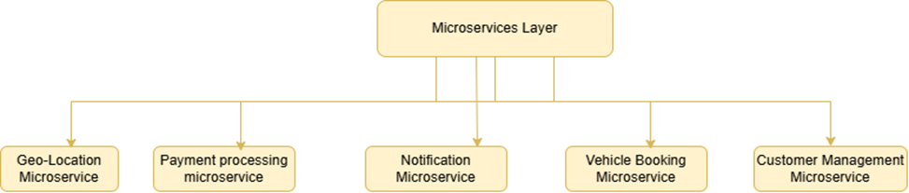
Figure 4.1 Agile Methodology

Process Flow/Representation
The process flow of Rento Car provides a step-by-step view of how users interact with the system. From logging in and browsing cars to booking a vehicle and tracking its delivery, each action is
part of a well-defined workflow. The flowchart helps visualize key system operations such as registration, car booking (with or without a driver), real-time vehicle tracking, and admin management of cars and customer data. [5]

User Registration & Login (Mobile App)
- Users begin by registering on the mobile app, entering required personal information (e.g., name, phone, CNIC).
- After registration, they log in using their credentials (email/phone + password or OTP).
- The system verifies login details and grants access upon successful validation.

User Dashboard (Mobile App)
Once logged in, users land on their dashboard.
From here, they can:
- Manage Bookings: View or cancel upcoming/past bookings.
- Book a Car: Start a new rental process.

Car Booking Flow (Mobile App)
- Users initiate the booking by selecting a car, date, and duration.
- They confirm the booking details.
- The app redirects to a secure payment screen.
- Upon successful payment, a confirmation screen is displayed.

Car & Trip Tracking (Admin Web Panel)
After booking, car tracking is handled only by the admin via the web dashboard.
The admin can:
- Monitor the real-time location of all rented vehicles.
- Track rental duration and trip progress.
- Flag unusual activity if needed.

Car Return Process (Mobile App)
- After the trip ends, users follow the return process through the app.
- A return confirmation is sent to both the user and the admin.
- Vehicle status is updated in the admin panel.

Logout & Session Termination
- After managing or completing bookings, users can log out of the app.
- This ends the session and secures user data.

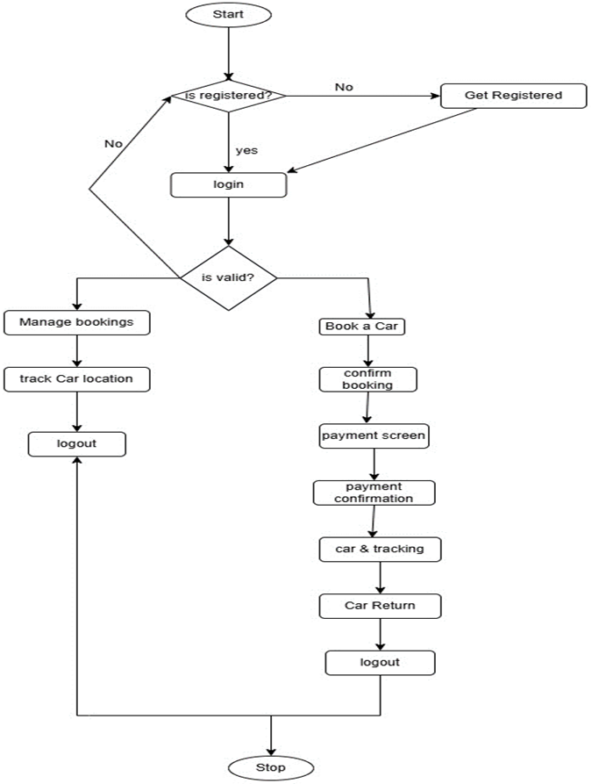
Figure 4.2 Flow-chart

Sequence Diagram
The sequence diagram shows the order of interactions among different system entities in Rento Car. It explains how the app functions over time when a user performs actions like logging in,
searching for a car, making a booking, and tracking the rented vehicle. This ensures that both frontend and backend components are well-synchronized for efficient service delivery.

Registration and Login Process:
- Customer logs into the system or registers if they are a new user.
- The system handles registration and login validation.

2. Booking Process:
- Customer initiates a booking request.
- Admin receives and processes the booking.

Car Return Process:
- Customer initiates a car return.
- Admin confirms the return and updates the return status in the system.

Payment Management:
- Admin adds or edits customer payment details.
- The system allows the admin to:
  - Update payment information
  - Delete payment history if required

Customer Management:
- Admin adds or edits customer details.
- The system provides options to:
  - Update existing customer information
  - Delete customer entries from the database

Car Fleet Management:
- Admin adds or edits car details in the fleet.
- The system allows:
  - Updating existing car information
  - Removing a car from the fleet

4.47 Report Generation:
- Admin generates reports related to rental and payment summaries.
- The system compiles and displays relevant data.

Conclusion:
This sequence diagram helps visualize the overall workflow of a car rental system. It clearly separates user actions (Customer/Admin) and system responses across various modules, ensuring efficient operation management and clarity in system design.

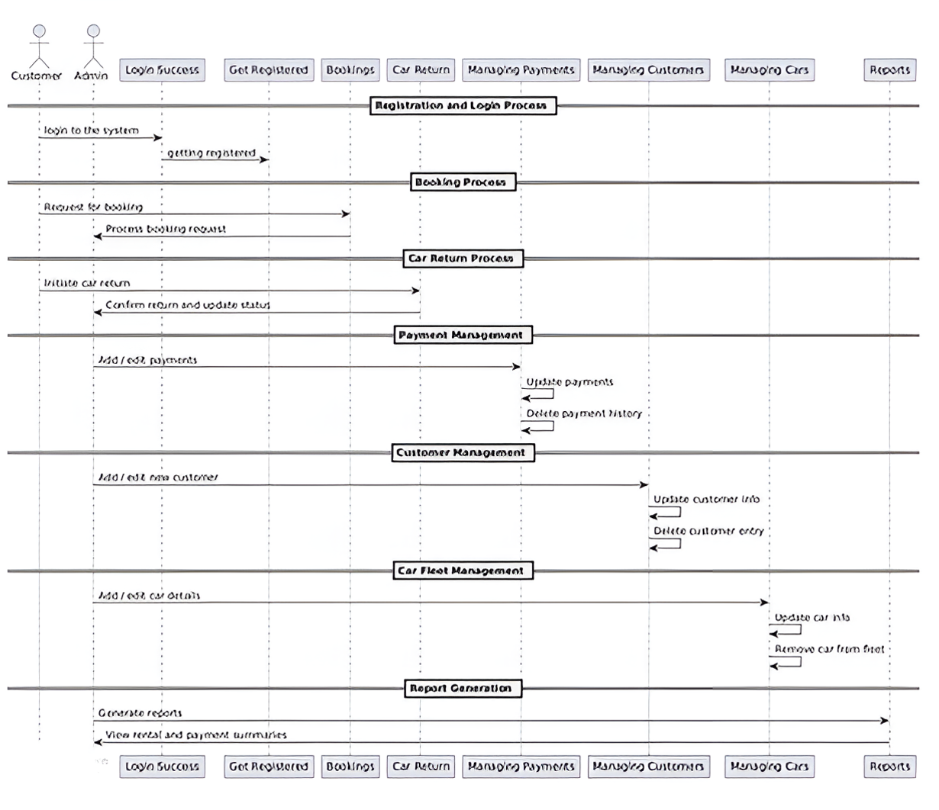
Figure 4.3 Sequence Diagra

Class Diagram
The class diagram presents a structural blueprint of Rento Car. It defines the main classes such as User, Admin, Car, Booking, Payment, and Tracking, along with their attributes and relationships. This diagram is useful for backend developers to understand the data flow and interactions among system entities.

Login & Signup Modules:
- The Login and Signup entities manage the authentication and registration process.
- Users provide their credentials, which are stored in these tables.
- Login includes methods like login() and resetPassword().
- Signup allows new users to register with details like username, email, phone, and password.

Customer Entity:
- Stores detailed customer information such as name, email, password, phone, address, and driving license.
- Connected to Booking, Payment, Invoice, and other entities through customer_id.
- Methods allow customers to:
  - View car data
  - Make or cancel bookings
  - Make payments
  - Initiate car returns

Admin Entity:
- Admin has full control over the system.
- Can manage customers, cars, bookings, payments, and returns.
- Functions include:
  - Approve/reject bookings
  - Manage car fleet and rental agreements
  - Process payments and car returns
  - Generate reports

Booking Entity:
- Central table that records every car booking made by a customer.
- Contains foreign keys: customer_id and car_id.
- Stores booking dates, rental costs, and status.
- Connected to RentalAgreements, CarReturn, Payment, and Invoice.

Car Entity:
- Represents all vehicles available for rent.
- Stores car details such as model, make, year, price per day, and current location.
- Admin can add, update, or remove cars from this table.

Payment Entity:
- Records payment information for each booking.
- Connected to both Customer and Booking via foreign keys.
- Stores payment amount, date, and status.
- Allows functions like processPayment() and refundPayment().

Rental Agreements Entity:
- Contains legal agreement details linked to each booking.
- Attributes include terms and whether the agreement is signed.
- Ensures legal compliance for each rental.

Car Return Entity:
- Manages car return data.
- Stores return date, condition, status (e.g., late return), and calculated fees.
- Helps track vehicle return history and status updates.

Invoice Entity:
- Stores invoice records for completed bookings.
- Includes total rental cost and issue date.
- Connected to both Customer and Booking.

Tracking Entity:
- Tracks the real-time location of each car.
- Includes timestamp and location information.
- Useful for monitoring vehicle movement and ensuring security.

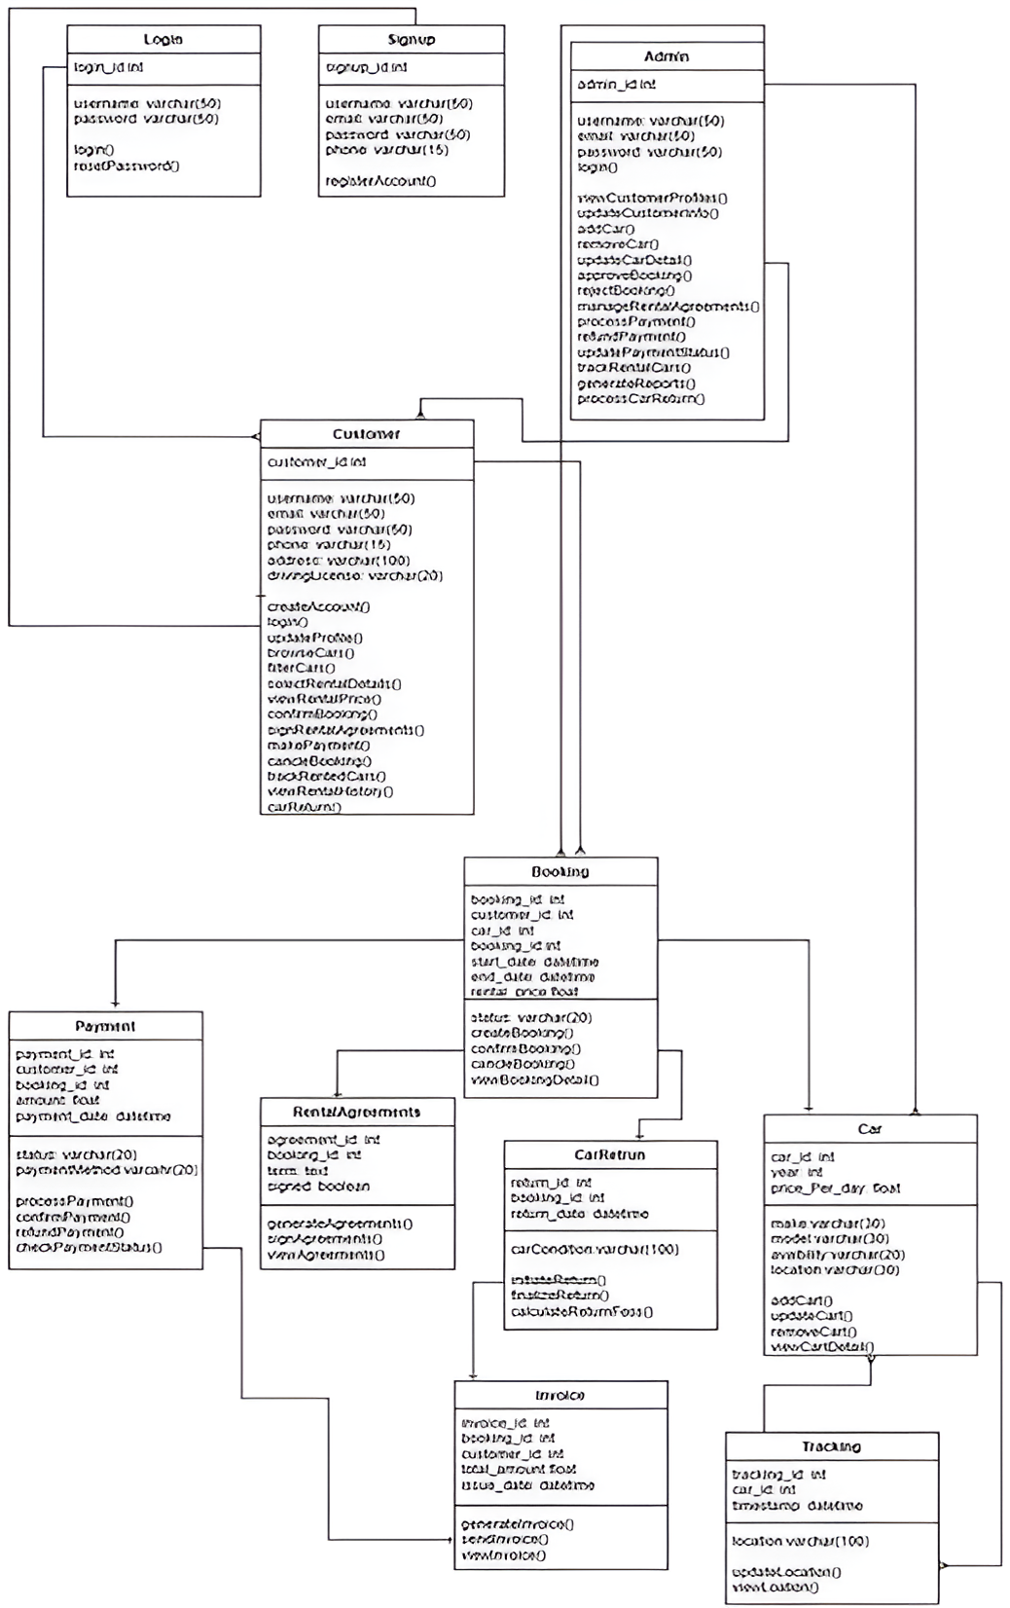
Figure 4.4 Class Diagram

Data Flow Diagrams

Level 0 DFD
Purpose:
The Level 0 DFD is the highest-level overview of the Rento Car system. It shows the main external entities (User and Admin) and how they interact with the entire system as a single process.
External Entities:
- User: A person who uses the app to book or rent a car.
- Admin: A person who manages cars, users, and booking records in the system.
Main System:
- Rento Car System: The central system that handles all core functionalities like bookings, cancellations, car management, user authentication, and payment processing.
Data Flows:
- User → Rento Car System:
Sends requests to use services such as car browsing, booking, payment, or cancellation.
- Admin → Rento Car System:
Sends data to manage the system, such as adding or updating car details, viewing bookings, or user management.

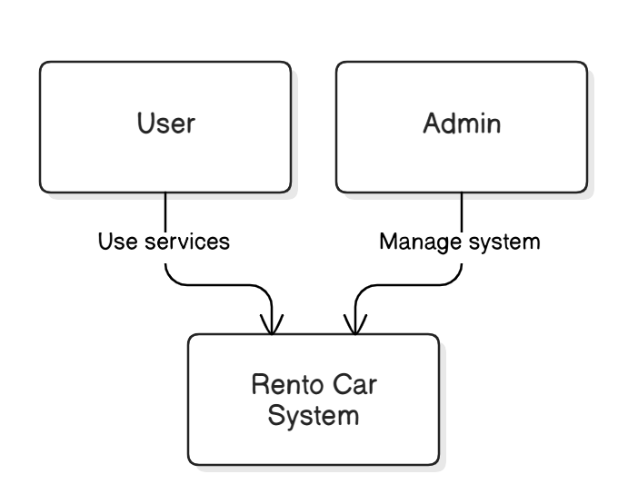
Figure 4.5 Data Flow diagram Level0

Level 1 DFD
Purpose:
This Level 1 DFD shows the main processes of the Rento Car system. It gives a high-level view of how users and admins interact with the system.
External Entities:
- User: A person who uses the Rento Car app to search, book, or cancel a car.
- Admin: The person who manages the system, cars, and bookings.
Main Processes:
- User Authentication:
Handles user login and verifies credentials.
- Car Selection & Booking:
Allows users to browse cars, check availability, and book.
- Admin Management:
Lets the admin manage car inventory and user bookings.
Data Flows:
- The User interacts with the system by logging in and booking cars.
- The Admin logs in to manage bookings and update car data.
This DFD helps understand who interacts with the system and what main tasks they perform

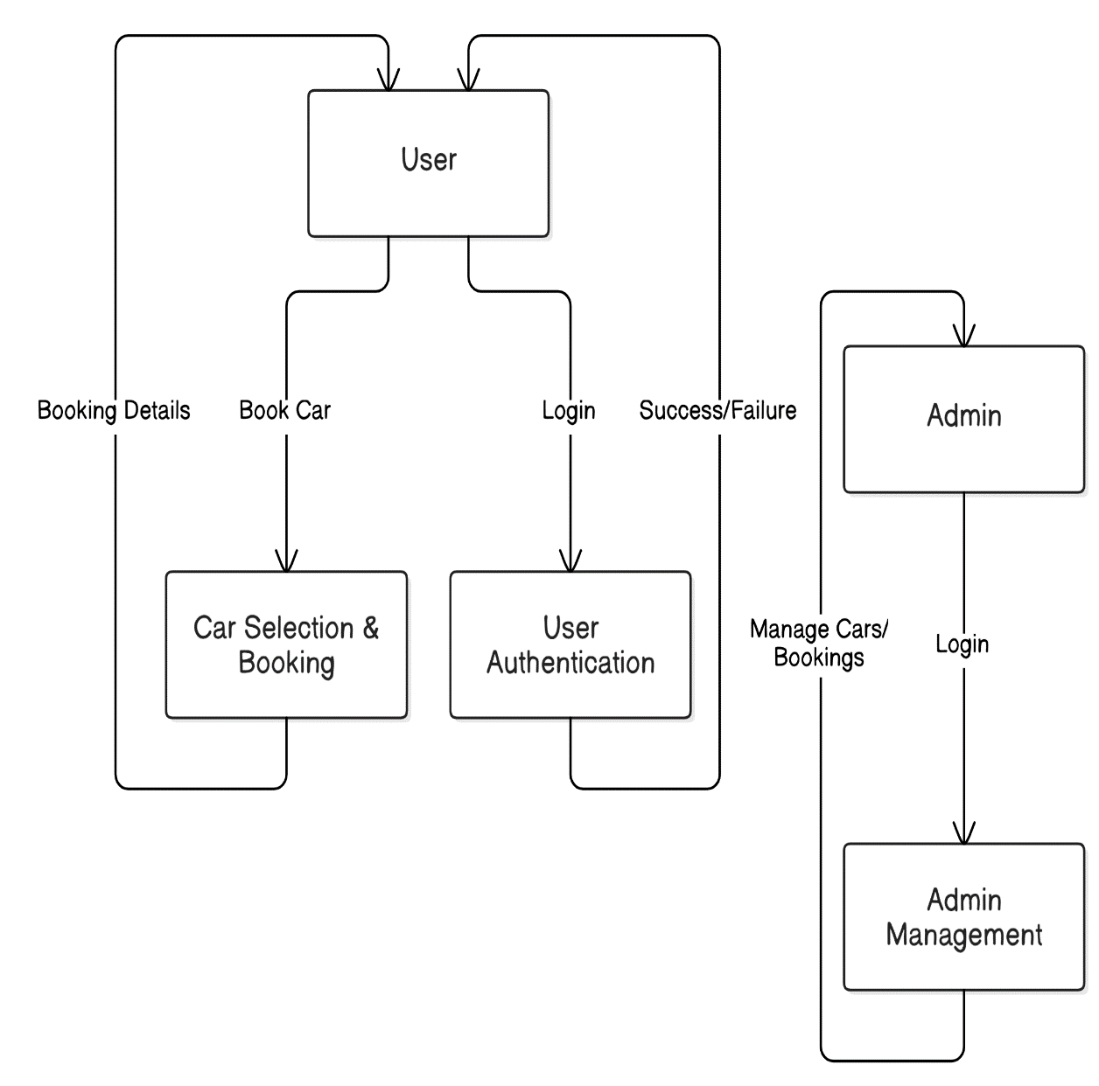
Figure 4.6 Data Flow Diagram Level1

Level 2 DFD Explanation
Purpose:
The Level 2 DFD provides a more detailed breakdown of the booking flow. It shows all major steps involved in booking and managing a car rental.
External Entities:
- User: Interacts with the system to book or cancel a car.
- Admin: Handles bookings and updates car details.
Main Processes:
- Login:
The user or admin enters login details to access the system.
- Browse Cars:
Users can view available cars.
- Select Car & Check Availability:
Users pick a car and the system checks its availability.
- Enter Booking Info:
User provides booking details like date, time, and duration.
- Make Payment:
User pays for the selected car.
- Booking Confirmed:
System confirms and stores the booking.
- Cancel Booking:
Users can cancel bookings.
- Admin Actions:
Admin logs in, manages bookings, and updates car inventory.
Data Flows:
- The User goes step-by-step from login to payment.
- The Admin has access to management processes for handling bookings and cars.
This diagram shows how data flows within the system and breaks down the user journey into multiple small steps.

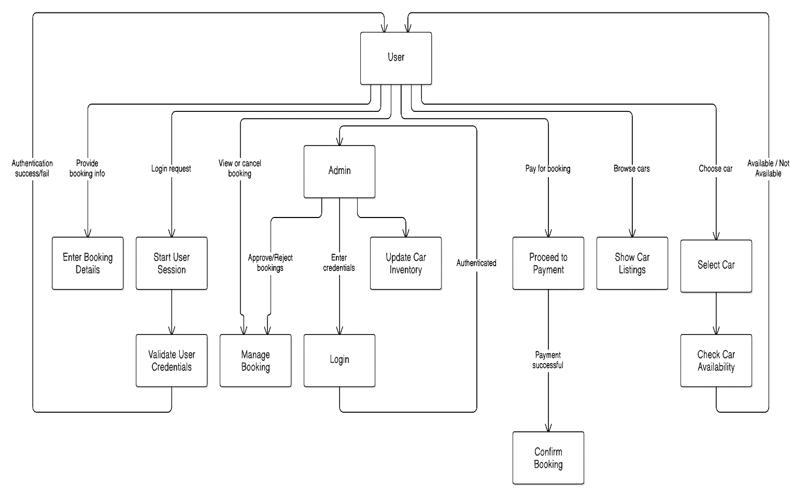
Figure 4.7 Data Flow Diagram Level2

Chapter 5

Implementation

Implementation
The The implementation of RentoCar follows a scalable, modular, and cloud-integrated architecture, leveraging both mobile and web technologies to offer a seamless rental experience for users and operational control for administrators. The architecture is built using Flutter, React, and Firebase, ensuring real-time data handling, secure authentication, and modern UI/UX across platforms.
- Authentication Module
User and admin authentication is handled through a combination of Firebase Authentication and custom logic for enhanced security and usability.
- User Authentication:
  - Users register via their mobile numbers, with SMS-based OTP verification to ensure identity authenticity.
  - OTP-based login avoids the need for password management, streamlining user onboarding and improving security.
  - Session tokens and authentication states are securely managed using Firebase’s built-in session handling.
- Admin Authentication:
  - Admins access the system via a secure web portal, logging in with verified email/password credentials.
  - Admin roles and permissions are managed via Firebase Authentication and Firestore rules.
This dual-mode approach provides strong access control and a simplified user experience.
- User Mobile Application (Flutter)
The RentoCar mobile application is developed using Flutter, providing a single codebase for Android and iOS platforms. The app offers a full set of features designed with user experience and functionality in mind.
- Cross-Platform Compatibility: Ensures smooth and consistent user experience on both Android and iOS.
- Booking and Payments: Users can browse, book, and pay for rentals directly from the app.
- Form Validation:
  - CNIC scanning is integrated using the cnic_scanner package.
  - Custom regex-based validation ensures valid CNIC and phone formats.
- Location Services:
  - Google Maps Autocomplete helps users accurately select pickup/drop-off points.
  - Future integration includes real-time driver tracking and delivery notifications.
The app uses Material Design principles for a clean, intuitive interface with minimal learning curve for end users.
- Admin Web Dashboard (React + Firebase)
The Admin Dashboard is a robust web-based panel built using React for frontend development and Firebase for backend data handling.
- Booking Management: Admins can view, approve, or reject bookings in real-time.
- Vehicle Management: Add, update, or remove car listings, including availability status and pricing.
- Tracking & Metrics:
  - Integration with Google Maps API allows live tracking of all rented vehicles.
  - Location history and route logs can be accessed per vehicle.
- User Verification: Admins can verify CNICs and documents uploaded by users.
- Analytics Dashboard (Planned): Charts for rental trends, earnings, and user growth will be incorporated.
The dashboard is hosted via Firebase Hosting, ensuring global availability and fast load times.
- Car Booking & Payment Integration
Car rental bookings are a core part of the application, tightly integrated with a secure payment system.
- Real-Time Availability: Vehicle inventory is synced with Firestore, ensuring up-to-date availability.
- Booking Logic:
  - Users can choose the booking duration, pick-up/drop-off time, and car type (with or without driver).
  - Booking requests are confirmed via Firestore and admin approval.
- Payment Integration:
  - The app uses Stripe to process payments securely.
  - Transactions are encrypted and stored with timestamped logs for audit purposes.
The system is built to support future payment options such as Easypaisa, JazzCash, and bank transfers.
- Real-Time Car Tracking (Admin End)
To improve fleet security and delivery accuracy, the admin panel includes live tracking of all rented vehicles.
- Live GPS Tracking: Captures the vehicle’s real-time position using either the user’s app or an integrated IoT device.
- Dashboard Display:
  - Google Maps within the admin panel shows current location and movement trail.
  - Admins can view estimated time of arrival or delivery.
- Geo-Fencing (Planned):
  - Admins will receive alerts if a vehicle exits a predefined boundary.
  - Useful for monitoring usage violations and unauthorized travel.
These features improve operational oversight and ensure customer safety.
- Database Integration
The entire system uses Firebase Firestore, a NoSQL document-based cloud database, for storing and managing structured data.
- Data Collections:
  - users – Stores user profiles, CNICs, and preferences.
  - cars – Maintains car details including availability, pricing, and status.
  - bookings – Logs each rental with timestamps and payment data.
- Subcollections:
  - Nested subcollections like users/{userId}/bookings provide scalable and efficient querying.
- Media Handling:
  - CNIC scans, car photos, and other documents are stored using Firebase Storage.
Firestore ensures real-time syncing between the app, dashboard, and backend with built-in offline support.
- Security & Compliance
Security is built into every layer of the application to protect user data and maintain platform integrity.
- Encryption:
  - All data is encrypted in-transit (HTTPS) and at rest using Firebase’s secure architecture.
- Access Control:
  - Firestore security rules restrict users to their own data.
  - Admins have elevated access defined via custom claims.
- OTP-Based Login: Ensures verified identities and prevents unauthorized access.
- Compliance:
  - The system adheres to local data protection laws and best practices in cloud security.
  - Regular security audits and updates are scheduled.
- Deployment & CI/CD
The deployment process is automated using modern DevOps practices to ensure fast and stable releases.
- Flutter App:
  - Deployed to the Google Play Store and Apple App Store.
  - Uses GitHub Actions for CI/CD, with automatic builds on push.
- Admin Panel:
  - Hosted on Firebase Hosting, ensuring low-latency global delivery.
  - Auto-deployed on code commits via GitHub integrations.
- Version Control:
  - Git-based branching strategy for development, staging, and production.
This setup supports faster development cycles and reduces downtime during updates.
- Scalability & Roadmap
The system is designed with future expansion in mind, supported by Firebase’s serverless, auto-scaling architecture and Flutter’s flexible UI system.
Planned Features:
- In-App Chat:
  - Real-time messaging between users and support agents.
  - Powered by Firebase Realtime Database or third-party solutions like Stream.
- AI-Based Recommendations:
  - Machine learning models will analyze booking history to suggest relevant vehicles.
  - Improves user engagement and satisfaction.
- Subscription Plans:
  - Monthly rental packages and long-term lease options.
  - Integration of promotional codes and referral bonuses.
These enhancements will keep the platform competitive and ready for evolving customer demands.

User Registration Algorithm
The User Registration Algorithm is a key part of the Rento Car system, ensuring that onboarding is smooth, secure, and efficient. Upon launching the mobile application, users are prompted to register using their mobile number, which is authenticated through Firebase Authentication.
Key Steps:
- User enters a valid phone number.
- An OTP (One-Time Password) is sent for verification.
- Upon successful OTP verification:
  - A new user record is created in Firebase Firestore.
  - A user role (customer/admin) is assigned for role-based access.
  - Basic profile details like name, CNIC (optional at signup), and location are stored securely.
- The user is redirected to the Home Screen to access car listings, bookings, or shipping modules.
Admins have access to a centralized dashboard to view, monitor, or manage all registered users.

Real-Time Booking Data Management
Rento Car uses Firebase’s real-time database to handle booking-related data. This includes live updates on car availability, booking confirmations, and rental status. Users always interact with the most updated information without needing to refresh the app.
Whenever a user books a vehicle:
- The selected car’s status is instantly marked as “Booked.”
- A unique booking ID with a timestamp is generated and stored in Firestore.
- The database updates are automatically reflected across all user and admin interfaces.
- Notifications are sent to both user and admin for confirmation.
This ensures consistency, speed, and transparency in the booking process.

Security and Data Protection
Security is a top priority throughout the development of the Rento Car system. All user data, including authentication details, booking information, and payment history, is securely encrypted using Firebase’s built-in security protocols.
Security Measures:
- End-to-end encryption for data in transit and at rest.
- Role-based access control to prevent unauthorized data access.
- OTP-based login for secure and password-free authentication.
- Firestore security rules ensure that users can only access their own data, while admins have extended privileges.
The system is compliant with general data protection standards, minimizing the risk of breaches.

User Interface
The user interface is designed to be intuitive, modern, and user-friendly. The following core screens represent the typical user journey in the Rento Car mobile application:
- Welcome Screen: Introduces users to the app and highlights its key services.
- Signup & Login Screens: Allow new users to register and existing users to sign in.
- Home Page: Offers navigation to key features like booking, shipping services, and the user profile.
- Car Listings Page: Displays available vehicles with detailed information such as pricing, location, and model.
- Booking Confirmation Page: Shows confirmation details and generates a digital receipt for the user.

Welcome Screen
The Welcome Screen serves as the first interaction point for users. It contains a title that clearly states the app’s purpose: “Book Your Ride or Ship a Vehicle – Anytime, Anywhere.”
Below the title, the core services are listed to immediately inform the user of what they can expect from the platform:
- Rent cars with or without a driver.
- Get your vehicle delivered to your doorstep.
- Secure, fast, and user-friendly booking experience.
These features reflect Rento Car’s commitment to flexibility, safety, and convenience in its vehicle rental and delivery services.
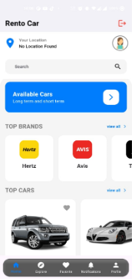
Figure 5.1 Welcome Screen

Car Booking & Shipping Interface:
This screen is designed to showcase the core functionality of the app, allowing users to either browse rental cars or schedule vehicle shipping. The heading “Choose Your Ride or Schedule a Pickup” clarifies the app’s multifunctional nature.
Users can explore detailed vehicle listings complete with images, specifications, pricing, and real-time availability. For shipping, users can request pick-up services for their vehicles, with integrated live tracking to monitor the shipment’s progress.
The description explains:
“Explore various cars, check availability, and make bookings instantly. You can also ship your own vehicle with live tracking and secure handling through our trusted delivery network.”
The interface prioritizes ease of navigation, with filters to sort vehicles by type, price, and location, as well as calendar integration for scheduling
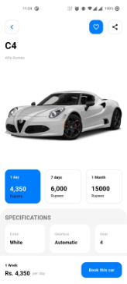
Figure 5.2 Booking Screen

Sign Up
The Sign Up screen is designed to guide new users smoothly through account creation. The consistent display of the “Rento Car” brand name at the top strengthens brand recognition.
The heading “Create Your Account” clearly instructs users on the next steps. The sign-up form includes fields for entering a valid email address, creating a strong password, and confirming the password to reduce entry errors.
Additional features include password strength indicators and validation messages to help users create secure credentials. The screen offers a helpful link for returning users: “Already have an account? Login,” enabling easy navigation.
At the bottom, a clearly visible “Sign Up” button allows users to submit their details securely, after which they gain immediate access to the app’s full suite of services.
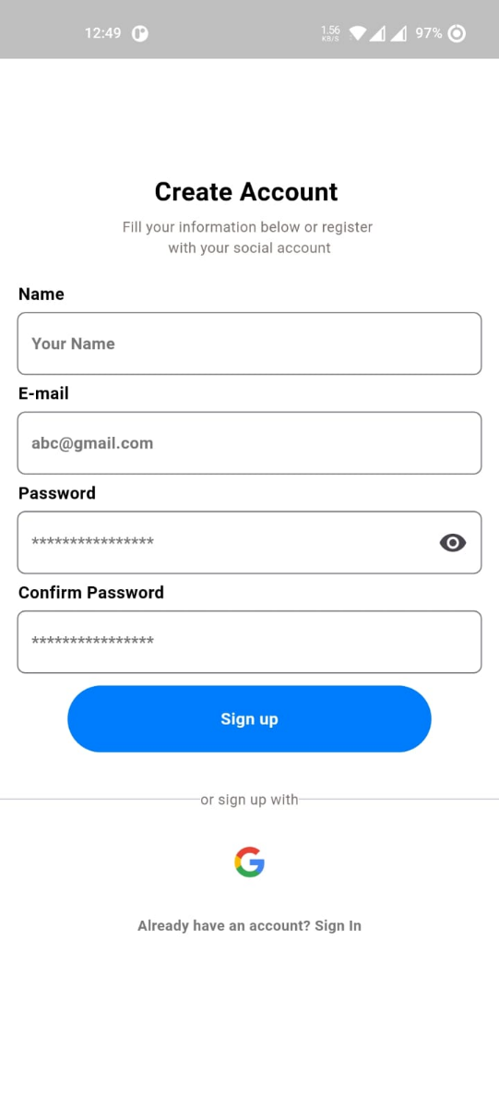
Figure 5.3 Sign Up Screen

Login
The Login screen focuses on quick and secure access to existing accounts. The brand name remains prominent to reassure users of the platform’s authenticity.
Users enter their email and password credentials, with input fields designed for clarity and accessibility. The screen includes a “Forgot Password?” link, providing a secure password recovery process through email verification.
Two buttons at the bottom “Login” and “Sign Up”allow users to either proceed with authentication or register a new account, minimizing confusion and streamlining user flow.
The interface supports accessibility features such as larger font sizes and voice-over compatibility to accommodate users with different needs.

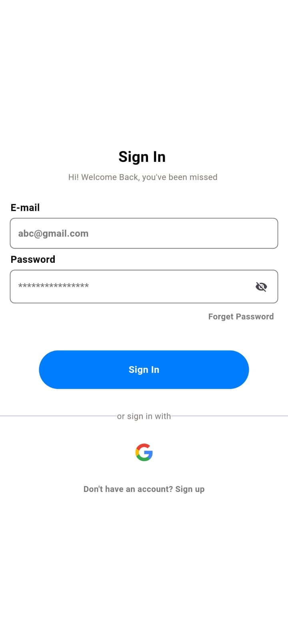
Figure 5.4 Login Screen

Location Access & Search
This screen highlights Rento Car’s integration with location services to enhance user convenience. Upon launch or during booking, the app automatically detects the user’s current location with high accuracy using GPS technology. This enables faster and more relevant results when searching for nearby available cars or selecting a pickup and delivery address.
The location interface includes a search bar, allowing users to manually enter or select a location anywhere in Pakistan. Suggestions are provided through Google Places API, ensuring reliable and real-time location data.
Text under the location widget reads:
“Detect your location or search manually to find the best rides near you.”
This functionality ensures users receive location-aware service options tailored to their area, streamlining the booking process and making it more efficient.
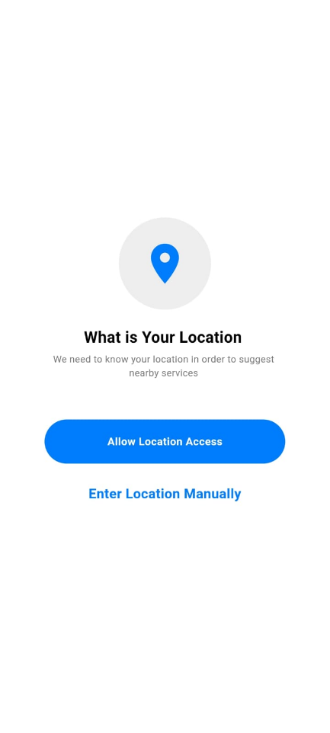
Figure 5.5 Locations Screen1

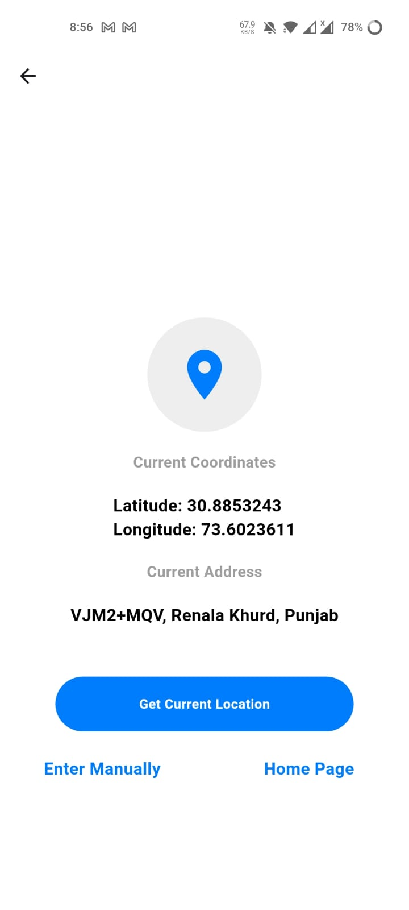
Figure 5.6 Location Screen2

Home Screen
The Home screen acts as the user’s central dashboard after login. A label “DEBUG” indicates ongoing development, reflecting the team’s commitment to continuous improvement.
Main sections include:
- Available Cars: Displays a curated list of vehicles ready for booking, with quick access to detailed views and booking options.
- Your Bookings: Summarizes all current, upcoming, and past bookings, allowing easy management and tracking.
- Email ID: Shows the user’s registered email, reassuring them of their logged-in status.
- Logout: Provides a secure exit point from the app, ensuring user data privacy.
The layout is clean and well-organized, with a navigation bar or menu for accessing other key areas such as profile settings, support, and notifications.
This screen serves to keep users informed and in control, improving overall engagement and satisfaction.


Figure 5.7 Home Page

Chapter 6

Testing and Evaluation

Testing
Testing is a critical phase in the development of the Rento Car system to ensure quality, functionality, usability, and performance. Multiple testing strategies were implemented, including unit testing, manual testing, functional testing, integration testing, and system testing. These tests validate both individual components and the entire system in real-world scenarios.

Unit Testing
Unit testing was carried out to validate the smallest components of the Rento Car application independently. The main purpose of this testing was to ensure that each individual function, class, or module performs its expected operation in isolation from the rest of the system.
For instance, the user registration feature was tested to ensure that new users could register successfully using valid credentials. The booking handler was tested to confirm that a user could book a car without a driver for specific dates and that the booking data would be accurately saved to the system. The real-time location tracking module was tested to verify it showed the current position of the booked vehicle accurately using GPS integration.
Payment processing was also tested with valid card details to ensure secure and smooth transactions. In addition, the feedback module was tested to make sure that user feedback is submitted, stored, and acknowledged correctly. Overall, unit testing helped identify and fix bugs early in development and ensured that core functions of the app were working before they were combined with other modules.
Table 6.1 Unit Testing
Test Case ID | Test Case Name | Test Description | Expected Result | Actual Result
UT-001 | User Registration | Register a new user account with valid credentials.. | User is successfully registered. | User registered successfully.
UT-002 | Vehicle Booking Handler | Book a car without a driver for selected dates. | Booking is created and stored correctly. | Booking saved successfully.
UT-003 | Location Tracker | Track location of a booked vehicle in real-time | Accurate location is displayed. | Real-time location shown.
UT-004 | Payment Processor | Test payment processing with valid card details. | Payment is processed and confirmed. | Payment processed successfully.
UT-005 | Feedback Submission | Submit feedback through the app. | Feedback is saved and acknowledged. | Feedback submitted successfully.

Manual Testing
Manual testing was used to assess the usability, interface design, and navigation of the Rento Car application from the perspective of a real user. Unlike automated testing, manual testing involves actual human interaction with the app to simulate real-world scenarios and workflows.
In this phase, testers manually uploaded new car listings from the admin panel, ensuring that images and details were correctly entered and displayed in the app. The full booking flow was tested, from searching for a vehicle to selecting a delivery option and completing the booking, verifying that the user could complete the process without any issues.
Profile management features, such as updating user details like name, contact information, and password, were manually tested to ensure that changes persisted accurately. The vehicle shipping feature was also tested to simulate scheduling a car shipment between cities and confirming that it could be tracked properly after submission. Additionally, the interface's responsiveness was tested on various screen sizes and devices to confirm that the layout adapted smoothly without breaking or causing usability issues.

Table 6.2 Manual Testing
Test Case ID | Feature | Test Scenario | Expected Outcome | Actual Outcome
MT01 | Car Upload (Admin) | Upload a new car listing with images and details. | Car appears in the vehicle list. | Car uploaded and displayed.
MT02 | Booking Flow | Search and book a vehicle for delivery. | Booking completes without issues. | Booking successful.
MT03 | Profile Management | Update user profile information. | Changes saved correctly. | Profile updated.
MT04 | Vehicle Shipping Module | Schedule vehicle shipping from one city to another. | Shipping request created and tracked. | Shipment scheduled and tracking
MT05 | Responsive UI Test | Use the platform on various screen sizes. | UI adapts without breaking. | UI responsive on all devices.

Functional Testing
Functional testing was focused on evaluating whether the system meets all the defined functional requirements. It tested the application as a whole in real-world usage scenarios to ensure that the platform behaves correctly from end to end.
One key scenario tested was the complete registration and login process. Users were expected to create an account, log in, and access the application’s features without errors. Another important functionality tested was the booking and payment process. Testers selected a car, completed the booking, and proceeded through the payment gateway to ensure that a payment receipt was generated upon successful transaction.
Additional tests verified that users could update their account settings, such as email, password, and other profile details, and that these changes would remain intact across sessions. Security functionality was also validated by attempting to access restricted features like bookings or profile management without logging in, ensuring that unauthorized access was denied and that the user was properly redirected to the login page.
Table 6.3 Functional Testing
Test Case ID | Functionality | Test Case Description | Expected Result | Actual Result
FT-001 | Complete Registration Flow | Register a new user and log in | User is able to register and log in successfully | Registration and login successful
Ft-002 | End-to-End document handling | Select a car, book it, and complete payment | Booking confirmed and payment receipt generated | Booking completed as expecte
FT-003 | User settings | Update profile details (email, password, contact info) | Changes persist and reflect across sessions | Profile updated and persistent t
FT-004 | Security checks | Attempt to access booking features without login | Access is denied and user is redirected to login | Unauthorized access blocked

Integration Testing
Integration testing was performed to ensure that all individual components of the system interact properly with one another. The main goal was to test the flow of data and communication between connected modules to detect any issues arising from integration.
For example, the interaction between the booking system and the payment gateway was tested to ensure that after a car is selected and booking is initiated, the payment module is triggered automatically and the transaction completes smoothly. Another integration test combined the user registration, login, and dashboard modules to ensure that a user could register, log in, and access their personalized dashboard with the correct data.
The search engine was integrated with the vehicle listing module to allow users to search for available cars using specific filters such as city, price, or car type. Results had to update dynamically and display only the relevant cars. The vehicle tracking feature was also tested in combination with the map module, verifying that the current location of a rented car could be seen on a live map with accuracy.
A shipping module and notification system were tested together to confirm that when a user scheduled a vehicle shipment, the system would automatically send a confirmation notification once the request was accepted.
Table 6.4 Integration testing
Test Case ID | Components involved | Test case Description | Expected Result | Actual Result
IT-001 | Booking module + Payment system | Book a vehicle and initiate payment | Booking recorded, payment gateway triggered | Booking and payment successful
IT-002 | Registration + Login + Dashboard | Register, log in, and navigate to dashboard | Dashboard loads with user data | Navigation successful
IT-003 | Vehicle listing + Search engine | Search available vehicles using filters | Search results update according to filter criteria | Relevant results displayed
IT-004 | Vehicle tracking + Map integration | Track location of a rented vehicle in real time | Map displays accurate current location | Real-time location shown on map
IT-005 | Shipping module + Notification system | Schedule shipment and trigger confirmation alert | Notification sent after shipping request is accepted | Notification delivered and confirmed

System Testing
System testing involved evaluating the complete, integrated application as a whole. The aim was to ensure that Rento Car performs all intended functions correctly and consistently in a production-like environment.
A full system workflow was executed, covering user registration, car booking, payment processing, and real-time vehicle tracking to confirm that the entire flow works seamlessly without crashes or interruptions. Load testing was also conducted by simulating multiple users accessing and using the app simultaneously. The system remained stable and responsive even under high traffic, which demonstrated its scalability.
Recovery testing was performed by simulating unexpected crashes or system failures. The app was able to restore the last known state without data loss, indicating good fault tolerance and data integrity. The complete workflow of vehicle shipping, from scheduling to tracking, was tested to verify the efficiency and reliability of the logistics module.
Lastly, cross-module validations were performed to ensure synchronization between various modules, such as rental, payment, user profile, and notification services. All components worked harmoniously, reflecting proper data flow and communication across the system.
Table 6.5 System Testing
Test Case ID | System Components | Test case Description | Expected Result | Actual Result
ST01 | Full System Workflow | Execute end-to-end functionality: registration, booking, payment, and tracking | System performs all operations without failure | All functionalities performed as expected
ST02 | Load Testing | Simulate multiple users booking and tracking cars simultaneously | System remains responsive and stable | System stable under high load
ST03 | Recovery Testing | Simulate a system crash and test data recovery and continuity | System restores last known state with no data loss | Recovery successful no data loss
ST04 | Shipping Request Workflow | Test complete flow of scheduling and tracking vehicle shipment | Shipment flow executes properly | Shipment functionality works as expected
ST05 | Cross-Module Validation | Verify interaction between rental, payment, and notifications | Smooth cross-module communication and responses | All modules synced and functional

Chapter 7

Conclusion and Future Work

Conclusion and Future Work

Conclusion
The Rento Car application stands as a comprehensive, modern solution tailored to the growing demand for online car rentals and vehicle shipping services. Developed using Flutter for the front-end and Firebase for backend services and real-time database handling, the app delivers a responsive, fast, and scalable user experience.
The system enables users to:
- Seamlessly rent cars with or without a driver.
- Track their bookings and vehicle status in real-time using live GPS.
- Make secure online payments using integrated gateways.
- Manage their profiles and booking history with ease.
On the administrative side, the platform offers a robust back-office solution that allows admins to:
- Monitor user activity and booking trends.
- Add, edit, or remove car listings.
- View payment logs and rental statuses in real-time.
By bringing all essential services—rental, booking, payment, tracking, and communication—into one unified interface, Rento Car not only improves user convenience but also adds transparency, security, and efficiency to the car rental ecosystem. Whether used by individuals looking for short-term rentals or businesses managing vehicle logistics, Rento Car offers a solution that is intuitive, reliable, and built for scale.

Future Work
While the first version of Rento Car fulfills its primary objectives, there are ambitious plans to enhance its features, optimize performance, and deliver a more intelligent, user-centered experience. Upcoming developments aim to align the application with emerging technology trends and increasing customer expectations.

In-App Chat Support
To foster better communication between customers and service providers, a real-time in-app messaging system will be integrated. This chat module will:
- Allow users to contact the admin or car owner directly.
- Enable instant clarification on bookings, pickup/drop timing, and rental policies.
- Support chat history, push notifications, and file sharing (e.g., ID documents).

AI-Powered Car Suggestions
Rento Car will evolve into a smart platform by introducing Artificial Intelligence (AI) and Machine Learning (ML) to:
- Recommend cars based on user history, trip type, and budget.
- Detect repeat preferences (e.g., luxury, economy, SUV) for more relevant listings.
- Automatically filter and suggest deals, discounts, or featured cars based on location and peak travel times.

Vehicle Condition Reporting with Image Upload
To ensure transparency and accountability, both users and admins will have the ability to:
- Upload time-stamped photos before and after a ride.
- Attach optional comments to document any damages or issues.
- Compare condition reports to resolve disputes effectively.
This visual documentation system will serve as a digital checklist, building trust between renters and owners.

Enhanced Admin Dashboard (Web-Based)
An advanced, feature-rich web admin panel is under development to provide greater control and analytics. Planned functionalities include:
- Visual dashboards for booking statistics, user behavior, and income trends.
- Tools for car availability management and maintenance tracking.
- Fraud detection systems using pattern recognition and user behavior analysis.
- Admin permissions to manage roles, approvals, and critical actions.

Expansion of Payment Methods
To increase convenience for users across different regions, future updates will support:
- Integration with popular gateways like Stripe, JazzCash, Easypaisa, and PayPal.
- Support for wallet-based systems, promo codes, and installment plans.
- A secure tokenized system for storing payment methods.

Multilingual Support
Language inclusivity will be prioritized by adding:
- Built-in localization for Urdu, Arabic, and regional Pakistani languages.
- User-selectable language options during onboarding and settings.
- Translation APIs for dynamic text translation across the app.
This will make the app more accessible to a broader demographic, especially tourists and non-English speakers.

Integration with Advanced Map APIs
Future versions will feature deeper integration with Google Maps, HERE Maps, or similar platforms to offer:
- Live ETA (Estimated Time of Arrival)
- Dynamic traffic condition updates
- Intelligent route optimization for delivery or pickup vehicles
- Nearby service suggestions (e.g., petrol stations, service points)
This feature will significantly improve logistics and user planning.

Expanding Language Support
While the app currently supports English, future versions will introduce:
- Complete bilingual functionality (English and Urdu) in the UI.
- Voice-based prompts or instructions in regional dialects.
- Cultural sensitivity in language, layout, and design elements.
By prioritizing localization, Rento Car will be more inclusive and easier to use in rural or less tech-savvy regions.

Deeper Data Analyzer
To support decision-making and system optimization, a Data Analytics Module will be implemented. Key features include:
- Rental trend analysis: Track usage by time, car type, and user type.
- Smart alerts: Notify admins of anomalies or spikes (e.g., high demand during holidays).
- Customer behavior mapping: Identify common journeys, peak usage hours, and drop-off hotspots.
- Vehicle health prediction: Detect maintenance needs using usage frequency and travel patterns.
A dashboard-based visual analytics interface will help stakeholders make better business decisions, manage fleets efficiently, and predict future demand accurately.
In summary, the future roadmap of Rento Car is driven by innovation, user feedback, and scalability. Each planned feature aims to add value—whether by enhancing user satisfaction, streamlining admin operations, or making the service smarter and more personalized. With these improvements, Rento Car is well-positioned to become a leading car rental and shipping platform in Pakistan and beyond.
.

References
- Google, "Firebase: Backend Platform for App Development," Firebase, 2023. [Online]. Available: https://firebase.google.com
- Google, "Flutter: Cross-Platform UI Toolkit," Flutter, 2023. [Online]. Available: https://flutter.dev
- G. Roman, "Agile: Adapting to Needs of the Hour," IEEE, 2020, March 22. [Online]. Available: [IEEE Xplore Link] (Replace with actual DOI if available)
- G. f. Geeks, "Software Testing Fundamentals," 2014. [Online]. Available: https://www.geeksforgeeks.org/software-testing-basics/
- HERE Technologies, "Real-Time Location APIs," HERE Technologies, 2023. [Online]. Available: https://developer.here.com
- Stripe, "Secure Payment Processing," Stripe, 2023. [Online]. Available: https://stripe.com
- J. Nielsen, "Usability Engineering," Morgan Kaufmann, 1994. (Book reference, replace with actual UI/UX sources used)

